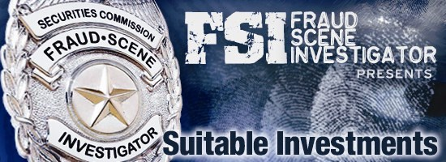

FSI: Fraud Scene Investigator

Guide for Teachers



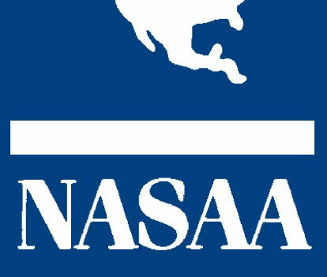

Sponsored by:

North American Securities Administrators Association, Inc.

In cooperation with:

Newspaper Association of America Foundation

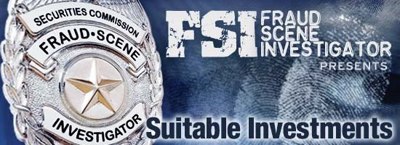

**THE FYI ON FSI**

**What is FSI**?

FSI stands for “*Fraud Scene Investigator*,” an interactive investor education program that teaches and empowers students how to detect and stop investment fraud, using a resource they’re most familiar with—the Internet.

**Where can I get it?**

The program, along with a corresponding *FSI Teacher’s Resource Guide*, is available free to educators for use in classrooms and at home through the NASAA website at [www.nasaa.org.](http://www.nasaa.org/)

**What will students learn?**

The FSI program is designed to help students learn how to fight fraud firsthand by delving into newspaper stock tables, researching companies through online news, and deciphering the truth of an investment from fraudulent sales pitches. In the initial FSI program, titled “Suitable Investments,” students help uncover a million-dollar fraud in progress and put the mysterious con man, “Mr. X,” behind bars.

**What resources are available for teachers?**

The *FSI Resource Guide for Teachers* (available at [www.nasaa.org](http://www.nasaa.org/) ) offers pre- and post-program student assessment surveys, definitions of investment terms, quizzes, and additional materials and suggestions to lead class discussions on how to research a company, what to look for in a company’s prospectus, and how to read a balance sheet.

**How does this fit into my curriculum?**

Fraud prevention is often an overlooked piece of many financial education courses. NASAA’s *FSI: Fraud Scene Investigator* program fills that need by integrating easily as a companion to other financial literacy programs, or functioning as a stand alone resource on investing and fraud prevention. *FSI: Fraud Scene Investigator* effectively rounds out financial literacy efforts by discussing how to protect the savings students have worked so hard to accumulate. The FSI program can serve as the capstone of any educator’s financial education efforts.

**How is it being distributed to schools?**

NASAA’s grassroots member investor education network is working with educators to integrate the *FSI* program into schools across the nation. In cooperation with NASAA, the Newspaper Association of America Foundation will assist in making the FSI program available to teachers throughout the United States through its Newspaper in Education (NIE) network of newspaper websites and resources.

**About NASAA**

NASAA ([www.nasaa.org](http://www.nasaa.org/) ) is the oldest international organization devoted to investor protection. Its membership consists of the securities administrators in the 50 states, the District of Columbia, Puerto Rico, the U.S. Virgin Islands, Canada, and Mexico.

**About the NAA Foundation**

The Newspaper Association of America Foundation’s ([www.naafoundation.org)](http://www.naafoundation.org/) program Newspaper in Education (NIE) is a cooperative effort between schools and newspapers to promote the use of newspapers as an educational resource. The NAA Foundation is the administrative organization for over 950 NIE programs in the United States.

FSI: Fraud Scene Investigator Teacher’s Guide

# Table of Contents

Mission Statement, Guidelines, Standards and Objectives. . . . 3

Pre & Post Program Assessment Quiz (w/ Answer Key) . . . . . . 4

## Chapter 1 Key Terms . . . . . . . . . . . . . . . . . . . . . . . . 8 Discussion Items . . . . . . . . . . . . . . . . . . . 9 Documents . . . . . . . . . . . . . . . . . . . . . . .11 Quiz (w/ Answer Key) . . . . . . . . . . . . . . 13

## Chapter 2 Key Terms . . . . . . . . . . . . . . . . . . . . . . . . 16 Discussion Items . . . . . . . . . . . . . . . . . . .17 Documents . . . . . . . . . . . . . . . . . . . . . . . 20 Quiz (w/ Answer Key) . . . . . . . . . . . . . . 24

## Chapter 3 Key Terms . . . . . . . . . . . . . . . . . . . . . . . 27 Discussion Items . . . . . . . . . . . . . . . . . . 28 Documents . . . . . . . . . . . . . . . . . . . . . . . 32 Quiz (w/ Answer Key) . . . . . . . . . . . . . . 36

## Additional Resources NASAA Fraud Center . . . . . . . . . . . . . . . . . 38

Mission Statement: FSI: Fraud Scene Investigator offers teachers and home users a non-commercial, online interactive investor education curriculum that may satisfy state and local education standards and objectives while encouraging the use of online news content and further individual research.

About This Program:

* States, provinces and local school systems are beginning to adopt personal finance as part of the core curriculum.
* Personal finance standards and objectives are being written and materials are being produced at an accelerated pace.
* New instructional material is being offered by numerous vendors, organizations and businesses covering a wide spectrum of personal finance subjects.
* Investor Education is a major element of personal finance.
* NASAA represents the top securities regulator in each state and province.
* The Newspaper Association of America Foundation’s Newspaper in Education program is working to bring more online content to both students and educators to meet the needs of the youth demographic.

Standards and Objectives:

* Understand an investment account statement.
* Search the Internet for corporate information.
* Examine a company’s stock chart and trading activity.
* Evaluate a company’s balance sheet, cash flow statement, and income statement.
* Identify investing terms.
* Research a brokerage company / individual broker.
* Utilize state / provincial securities regulator services.
* Describe consumer fraud tactics.
* Identify a common investment scam.
* Search online newspaper content.

FSI: Fraud Scene Investigator is a non-commercial investor education website produced for classroom and home use. This interactive learning experience was created by members of the North American Securities Administrators Association (NASAA), which represents state and provincial securities regulators in North America.

The story and characters used in this presentation do not represent any entity or person, alive or dead. This presentation is to be used for educational purposes only. Special thanks go to NASAA’s Investor Education Section, Youth Outreach Project Group and the West Virginia State Auditor’s Office for making this project possible.

STUDENT

# PRE & POST ASSESSMENT QUIZ

1. What information would you find on an investment account statement?

1. What information can you find about a company on the Internet and how do you know if the information is reliable?

1. What information does a stock chart provide?

1. What do a company’s balance sheet, cash flow statement, and income statement tell you?

1. Below is a list of investment terms. Please provide a brief description of the terms:

Prospectus

Small Cap Stock

Share

IPO

Return

Stock Chart

1. Where would you go to find information on a brokerage company, individual broker or investment adviser?

1. What services can your state/provincial securities regulators provide?

1. What are some techniques that con artists use to separate you from your hard-earned money?

1. List one common investment scam.

1. Where do you get your financial information?

STUDENT

# PRE & POST ASSESSMENT QUIZ Answer Key

1) What information would you find on an investment account statement?

Contributions

Withdrawals

Earnings/Losses

Previous Balance

Current Balance

Name of investment

Name and address of the investor

Account number

Portfolio allocation

Transactions

Number of shares held

1. What information can you find about a company on the Internet and how do you know if the information is reliable?

Information found online about a stock can include corporate and financial history, insider trades, analysts’ opinions, short position, news articles and much more. Always exercise caution and consider the source of the information received.

1. What information does a stock chart provide?

Stock charts will give you the volume of trading for the stock and the trading history. The stock chart does not tell you the financial health of the company.

1. What do a company’s balance sheet, cash flow statement, and income statement tell you?

A balance sheet lists the company's assets and liabilities, provided for the benefit of shareholders and regulators. It gives a snapshot, at a specific point of time, of the assets that the company holds and how the assets have been financed. A cash flow statement shows how the operations of a company have been financed during the accounting period, and how the financial resources have been used. The income statement is a summary of all the sales, expenses and net profits of a company over a set period of time.

1. Below is a list of investment terms. Please provide a brief description of the terms:

Prospectus: A legal document offering securities or mutual fund shares for sale, as required by the Securities Act of 1933. It must explain the offer, including the terms, issuer, objectives (if mutual fund) or planned use of the money (if securities), historical/financial statements, and other information that could help an individual decide whether the investment is appropriate. Also called offering circular or circular.

Small Cap Stock: Stocks with a relatively small market capitalization. The definition of small cap can vary among brokerages, but generally it is a company with a market capitalization of between $300 million and $2 billion.

Share: A share represents ownership in a company and the right to receive a share in the profits of that company. (also called a stock).

IPO (Initial Public Offering): The first offering of shares to the public by a privately owned company. IPOs are used by companies to raise new funds, or to achieve a listing on a stock exchange.

Return: The increase in value of an investment.

Stock Chart: A graph showing the price movement of a security over a given period of time.

(Each investment term is defined in the “key terms”).

1. Where would you go to find information on a brokerage company, individual broker or investment adviser?

NASAA www.nasaa.org

Individual state securities regulators

CRD (Central Registration Depository)

1. What services can your state/provincial securities regulators provide? Background/disciplinary/employment history on broker dealer firms, representatives and investment advisers. State regulators can also provide the registration and/or license status of the individuals and the investment products in your state.

1. What are some techniques that con artists use to separate you from your hard-earned money?

Con Artists:

* + Work to gain your trust and confidence.
  + Use high pressure sales or scare tactics.
  + Promise there are no risks and say the product is guaranteed.
  + Play on their victims emotions.
  + Forecast huge returns.

1. List one common investment scam.

Pump and dump scheme. (For more information please see NASAA’s annual list of Top Ten Investor Traps at

www.nasaa.org)

1. Where do you get your financial information?

Open-ended—intended for discussion. Some answers could include websites, the newspaper, etc.

CHAPTER ONE: Grandma’s House

# Key Terms

Account Statement: A record of transactions and their effect on account balances over a specified period of time for a given account.

Asset Allocation: The process of distributing investment funds among different kinds of assets such as stocks, bonds and cash to achieve the highest expected returns for the lowest possible risk.

Disclosure: A company's release of all information pertaining to the company's business activity and the investment, regardless of how that information may influence investors.

Return: The increase or decrease in the value of an investment.

Quarter: One of four three-month intervals on a financial calendar that together comprise the financial year.

Small Cap Stock: Stocks with a relatively small market capitalization. The definition of small cap can vary among brokerages, but generally, it is a company with a market capitalization of between $300 million and $2 billion.

Share: A share represents ownership in a company and the right to receive a share in the profits of that company. Also called a stock.

Suitability: A requirement that any investing strategy fall within the financial means and investment objectives of an investor.

IPO (Initial Public Offering): The first offering of shares to the public by a privately owned company. IPOs are used by companies to raise new funds, or to achieve a listing on a stock exchange.

Index: A composite of values designed to measure change in a market or an economy. Indices are usually created by measuring the value of a number of securities, or an economic indicator, at a certain date and letting that value be represented by 100. Changes in the index can be easily perceived in comparison with that 100 base number.

# Classroom Discussion Items Chapter 1 – Grandma’s House

## Subject: U.S. Postal Laws – Mail Fraud

Question: What are the penalties for mailing fraudulent documents through the U.S. Postal Service?

Answer: The penalties are up to a million dollars and up to five years in prison per incident. If the fraudulent documents are mailed to a financial institution, prison time can be up to 30 years. (See the Criminal Code, Title 18 section 13.41)

Question: Do courier or overnight shipping customers have the same penalties?

Answer: Sending fraudulent documents via overnight shipping exposes the sender to the same penalties as sending fraudulent documents through the U.S. Postal Service. Sending fraudulent documents via courier generally does not trigger any mail fraud penalties. However, if the telephone is used at any point in the process (i.e., a call is made to say that documents will be sent via courier at a certain time) then the same penalties that apply to sending fraudulent documents via the U.S. Postal Service may be imposed.

Question: What do Postal Inspectors do?

Answer: Postal Inspectors are federal law enforcement officers who make arrests and serve federal search warrants and subpoenas. The inspectors work with U.S. Attorneys and other law enforcement agencies and local prosecutors to investigate postal cases and prepare them for court. See link below for more information: http://www.usps.com/postalinspectors/missmore.htm

## Subject: Financial Statements – Footnote / Disclaimer

Question: What important information can you find in a footnote or disclaimer and why are they added to official documents?

Answer: A footnote is an explanatory note or comment to text in the body of a document. Footnotes are located either at the bottom of the page on which the text appears or at the end of the document. A disclaimer is boiler plate language that is added to sales materials and offering documents that denies the issuer's legal responsibility. Reputable companies use a disclaimer to inform investors of the limitations on the legal actions they can bring against the company. Companies engaged in investment fraud sometimes use disclaimers in an effort to show that their offerings are not subject to governmental regulation.

## Subject: Corporate Searches – Fraudulent Websites

Question: Who regulates the information available on the Internet?

Answer: There’s no single agency that controls the content of information posted on the Internet. However many agencies review Internet content as evidence of financial crime, including securities fraud such as a pump and dump scheme, and what’s known as West African fraud, etc. The ICANN (Internet Corporation for Assigned Names and Numbers) manages the assignment of domain names and IP addresses. No one specifically regulates the content on all websites.

Question: How do you identify the country of origin in the web address? How can the identifier in the web address be misleading?

Answer: Web addresses include an extension that identifies the country of origin. For example, Sweden's extension is .se, Belgium's extension is .be, Australia's extension is .au, etc. The country of origin extension can be misleading because it is no guarantee that the company is actually located in

the identified country. A list of extensions by country can be found at http://www.iana.org/root-whois/index.html

Classroom Invitation: Postal Inspector



NIE Task: Search newspapers for articles about mail fraud.

# Chapter 1 Documents

## Account Statement Discussion Items

1. How long has Hanna been an investor?

Hanna is a new investor.

1. How much money has Hanna earned or lost?

Hanna has lost $2,654.28

1. What is a “Small Cap” stock?

Small Cap stocks are stocks with a relatively small market capitalization. The definition of small cap can vary among brokerages, but generally it is a company with a market capitalization of between $300 million and $2 billion.

1. Other than “Small Cap Stock,” name some other investment categories and describe them.

Bonds - A debt investment with which the investor loans money to an entity (company or government) that borrows the funds for a defined period of time at a specified interest rate.

Mutual Funds- A security that gives small investors access to a portfolio of equities, bonds and other securities. Each shareholder participates in the gain or loss of the fund. Shares are issued and can be redeemed as needed. (Mutual funds include a large range of types, including large cap, small cap, balanced, etc.)

Large Cap –Generally companies having market capitalization between $10 billion and $200 billion.

Penny Stock - A stock that sells for less than $5 a share but may also rise to as much as $10/share as a result of heavy promotion. Penny stocks are traded over the counter (OTC) but are not traded on any major exchange or stock market.

1. What does it mean to diversify one’s investments? Is Hanna diversified? Considering her retiree status, what percentage of Hanna’s investments should be invested in stocks, bonds or cash?

Diversifying one's investments means spreading out savings and investments over multiple categories (e.g., stocks, bonds and cash) in order to minimize the danger posed by an "up" or "down" period in any one of the categories. The greater one's diversification, the lower the exposure to risk. Hanna is not diversified. She is 100% invested in small cap stock. Generally investments should be spread out more evenly among the categories.

1. Hanna’s statement shows that she paid $.25 for each share of Unlikely Technology. A footnote indicates that the price includes transaction fees. If the shares actually cost $.23 a piece at time of purchase, how much did Hanna pay to the investment company in transaction fees?

$800.00

1. Account statements generally do not include a sales pitch. This one does. Are there any red flags in the sales pitch that should cause concern? If so, what are they?

Yes, the red flags are:

* + Opportunity to pre-order shares – suggests that Hanna has been selected for a special investment opportunity not available to everyone.
  + Forecasting returns of 200% to 500% - if it sounds too good to be true, it generally is.
  + Playing on emotions - "you are a preferred customer."
  + Scare tactics - "government interference."
  + High pressure - "call us today" – pressuring potential investors to hurry and invest before it is too late.

1. What is a disclaimer and how would a reputable company use one in their sales materials?

A disclaimer is boiler plate language that is added to sales materials and offering documents that denies the issuer's legal responsibility. Reputable companies use a disclaimer to inform investors of the limitations on the legal actions they can bring against the company. Companies engaged in investment fraud sometimes use disclaimers in an effort to show that their offerings are not subject to governmental regulation.

1. What is an IPO and why could it be considered higher risk?

IPO (Initial Public Offering): The first offering of shares to the public by a privately owned company. IPOs are used by companies to raise new funds, or to achieve a listing on a stock exchange. An IPO is considered high risk because it has been privately owned and therefore has not been under the scrutiny of regulators. IPOs are risky because the company is new to the market and will be subject to the fluctuations of the market for the first time.

10.What is an index and what stocks are included in it?

Index: A composite of values designed to measure change in a market or an economy. Indices are usually created by measuring the value of a number of securities, or an economic indicator, at a certain date and letting that value be represented by 100. Changes in the index can be easily perceived in comparison with that 100 base number. The S&P 500, DJIA, Russell 2000, and NASDAQ 100 are just a few examples of the numerous indices that exist.

Chapter 1

1. On the Suitable Investments statement, the asset allocation shows 100% Small Cap Stock. What does Small Cap mean?

1. What is an IPO and why are they considered a riskier investment?

1. What is an Index?

List 3 examples of indices. a.

b.

c.

1. If Hanna had diversified her investments, what might she have in her portfolio?

1. Kim looked up Unlikely Technology online. From what she found, do you think it is a scam or legitimate business?

Quiz

## Chapter 1 Answer Key

1. On the Suitable Investments statement, the asset allocation shows 100% Small Cap Stock. What does Small Cap mean?

Small Cap Stocks are stocks with a relatively small market capitalization. The definition of small cap can vary among brokerages, but generally it is a company with a market capitalization of between $300 million and $2 billion.

1. What is an IPO and why are they considered a riskier investment?

IPO (Initial Public Offering): The first offering of shares to the public by a privately owned company. IPOs are used by companies to raise new funds, or to achieve a listing on a stock exchange. An IPO is considered high risk because it has been privately owned and therefore has not been under the scrutiny of regulators. IPOs are risky because the company is new to the market and will be subject to the fluctuations of the market for the first time.

1. What is an Index?

Index: A composite of values designed to measure change in a market or an economy. Indices are usually created by measuring the value of a number of securities, or an economic indicator, at a certain date and letting that value be represented by 100. Changes in the index can be easily perceived in comparison with that 100 base number. The S&P 500, DJIA, Russell 2000, and NASDAQ 100 are just a few examples of the numerous indices that exist.

1. List 3 examples of indices.

* 1. S&P 500
  2. Dow Jones Industrial Average
  3. NASDAQ

1. If Hanna had diversified her investments, what might she have in her portfolio?

Diversifying one's investments means spreading out savings and investments over multiple categories (e.g., stocks, bonds and cash) in order to minimize the danger posed by an "up" or "down" period in any one of the categories. The greater one's diversification, the lower the exposure to risk. If Hanna had diversified her investments, her portfolio might include some or all of the following: stocks (mutual funds or individuals companies such as energy stocks, health care stocks, technology stocks, etc.), certificate of deposits, cash, money market funds, bonds, and U.S. Treasury Bills.

5.Kim looked up Unlikely Technology online. From what she found, do you think it is a scam or legitimate business?

Definitely a Scam!

CHAPTER TWO: Computer Lab

## Key Terms

Stock Market Game: A simulation game for the U.S. stock market developed to promote a better understanding of the financial investment system.

Pink Sheet Stock: Pink Sheet stocks are over-the-counter (OTC) securities that do not meet the listing standards required to trade on the NYSE, NASDAQ, or other major stock exchange due to their limited capitalization and/or the limited number of shares outstanding. With a few exceptions, Pink Sheet stocks are small, thinly-traded issues that often carry a great deal of risk.

Bankruptcy: A court proceeding in which the assets of an insolvent company or individual are liquidated.

Stock Chart: A graph showing the price movement of a security over a given period of time.

Balance Sheet: An accounting statement of a company's assets and liabilities provided for the benefit of shareholders and regulators. It gives a snapshot at a specific point of time, of the assets that the company holds and how the assets have been financed.

Income Statement: A summary of all the sales, expenses and net profits of a company over a set period of time.

Cash Flow Statement: A statement that shows how the operations of a company have been financed during the accounting period, and how the financial resources have been used.

Trading Volume: A term used to describe the total number of securities or contracts traded in any particular period.

Registration: The filing process a company performs in accordance with state/federal regulations, prior to offering a new issue to the public. This process enables the regulator to confirm that the issue meets all the regulatory requirements.

## Classroom Discussion Items Chapter 2 – Computer Lab

### Subjects: Corporate Reporting – 10k, 10Q, Prospectus

Question: What is the difference between a public and private company?

Answer: A private company is owned exclusively by an individual, family, or small group of people. A public company is a corporation that sells shares of ownership to the general public. (The Basics of Saving & Investing: Investor Education 2020).

Question What are the financial documents that public companies file and when? Who mandates reporting and what must be reported?

Answer: Companies making a new offering of securities must disclose information about the company’s financial condition and its operations in a registration statement. This information also is disclosed in the prospectus or offering document. The annual report filed on Form 10-K is the primary document you can use to research a company’s financial condition and its operations. The Form 10-K includes audited financial statements, a discussion of products and services, a review of operations, management discussion and analysis, and a discussion of the company’s major markets. The condensed financial statements included in the filings provide the company’s assets, liabilities and earnings per share. The quarterly reports filed on Form 10-Q will include unaudited financial statements as well as additional information about the company’s current financial position and operations. (See www.sec.gov for more information).

Question: Where can you find financial information?

Answer: You can find financial information in magazines, newspapers, websites, and reports issued from companies. Exercise caution and consider the source of the information received.

NIE Task: Find local and national companies that offer stock. Find their Investor Relations webpage. What information does the company offer to investors?

### Subject: Stock Exchange

Question: What is a stock symbol?

Answer: A stock symbol is a group of letters standing for a particular stock, mutual fund, or other security. Also called a ticker symbol or stock abbreviation.

Question: What must a company do to be listed on a stock exchange?

Answer: Companies must comply with filing requirements of state and federal law as well as the exchange on which they wish to be listed.

Question: What are the major stock exchanges in the U.S. and overseas?

Answer: The three most widely known exchanges are the NYSE, NASDAQ, and AMEX. In the U.S., there are also regional exchanges (i.e. Boston, Philadelphia), commodities markets (i.e. NYMEX, CBOT). In addition, there are international exchanges in London, Toronto, Tokyo and elsewhere.

Question: Which stock exchanges have a trading floor? How do they operate?

Answer: The NYSE is a floor-based exchange in which traditionally the investor’s agent must be present to exchange stocks. To purchase company stock listed on the NYSE, the investor places an order through a stockbroker. The stockbroker relays the purchase to a floor trader who is on the exchange floor. The floor trader then purchases the stock. (The Basics of Saving & Investing: Investor Education 2020).

Question: Must a stock be sold at a stock market, or can you purchase a stock from the issuing company?

Answer: You can purchase stock from the issuing company, but you still must use a broker to facilitate the purchase.

Question: Why is a stock exchange called a “secondary market?”

Answer: A secondary market is a market in which an investor purchases a security from another investor rather than the issuer, subsequent to the original issuance in the primary market.

NIE Task: Find information about a stock exchange. How are changes made in the way stock markets regulate their listed companies?

### Subject: Trading Stock

Question: What does a stock chart tell you?

Answer: Stock charts will give you the volume of trading for the stock as well as and the trading history. The stock chart does not tell you the financial health of the company.

Question: What is stock capitalization (Stock Cap or Market Cap)?

Answer: Market capitalization is the overall value of all issued and outstanding shares of a publicly traded stock. (The Basics of Saving & Investing: Investor Education 2020).

Question: What is a “penny stock?”

Answer: Penny stocks are high-risk stocks that generally sell for less than $5 and are not listed and traded on any major exchange or stock market.

Question: How does a stock price movement demonstrate “supply and demand?”

Answer: Prices for goods and services in any market depend largely on the supply and demand of the product or service. Buyers seek to buy at the lowest possible price and sellers seek to sell at the highest possible price. So an increase in a stock price indicates that the demand for the stock has exceeded the supply at a particular price. (The Basics of Saving & Investing:

Investor Education 2020)

Question: What is a “short sale?”

Answer: A short sale is the sale of a security that the seller does not own. This is a speculative practice done in the belief that the price of a stock is going to fall and the seller will then be able to cover the sale by buying the security back at a lower price. The profit would be the difference between the initial selling price and the subsequent purchase price. It is illegal for a seller not to declare a short sale at the time of placing the order.

Question: What do analysts do?

Answer: Analysts are typically employees of a brokerage or fund management house who study companies and make buy-and-sell recommendations on securities of these companies. Most specialize in a specific industry.

NIE Task: Find the financial page in the newspaper and discuss the information listed about each stock. Go to a financial news website and discuss information listed there.

# Chapter 2 Documents

* Balance Sheet
* Income Statement
* Cash Flow

Balance Sheet

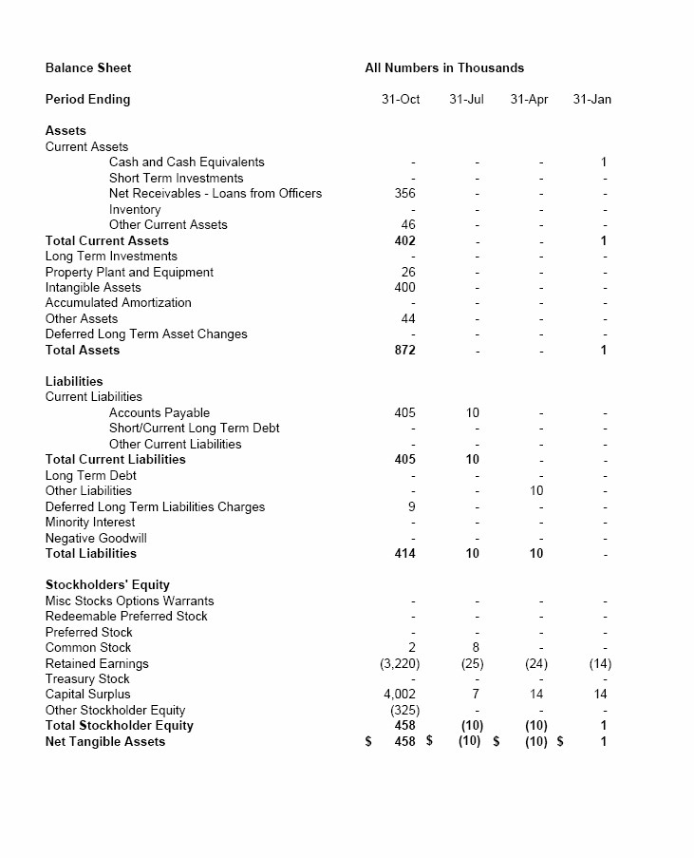

Income Statement

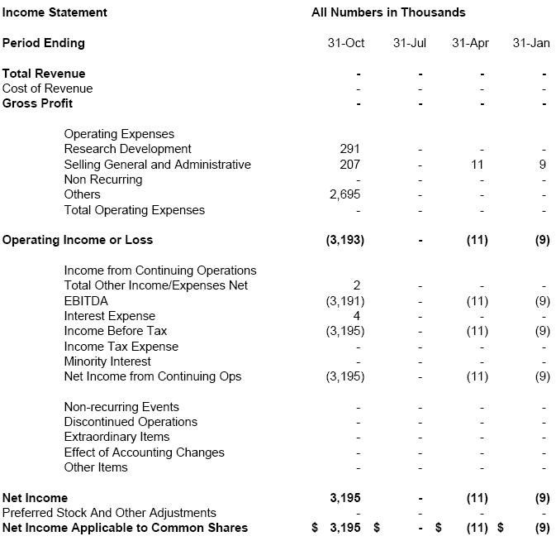

Cash Flow

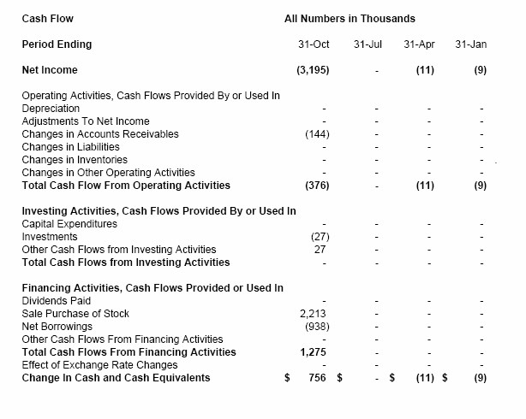

Quiz

Chapter 2

1. Mylo found the stock symbol for Unlikely Technology. What does the .pk stand for? What can be determined by the number of letters in a stock symbol?

1. Mylo goes online to find the financial statements associated with the stock. What other information can be easily found by looking up a stock online?

1. Balance sheets list assets and liabilities. What are some examples of each and how can they balance?

1. Income statements list EBITDA. What is that and why is it so important when determining a company’s financial health?

1. What was the amount for capital expenditures listed on the balance sheet?

1. Bonus question: What are capital expenditures?



1. Mylo found the stock symbol for Unlikely Technology. What does the .pk stand for? What can be determined by the number of letters in a stock symbol?

The .pk in the stock symbol identifies the stock as a pink sheet. The stock extension identifies the specific market on which the stock is traded. The letters in a stock symbol represent various characteristics about the stock. For example, one to three letters may indicate that the stock trades on either the NYSE or AMEX. Four or more letters may indicate that the stock trades on the NASDAQ or may represent a mutual fund.

1. Mylo goes online to find the financial statements associated with the stock. What other information can be easily found by looking up a stock online?

Information found online about a stock can include corporate and financial history, insider trades, analysts’ opinions, short position, news articles and much more.

1. Balance sheets list assets and liabilities. What are some examples of each and how can they balance?

Assets can include tangible items such as cash, property and equipment as well as intangible items such as goodwill. Liabilities can include outstanding debts and negative goodwill. The total of assets must equal liabilities plus owner’s equity.

1. Income statements list EBITDA. What is that and why is it so important when determining a company’s financial health?

EBITDA is an acronym that refers to a company's earnings before the deduction of interest, tax, depreciation and amortization expenses. EBITDA may demonstrate a more accurate picture of the company’s actual earnings.

1. What was the amount for capital expenditures listed on the balance sheet?

Zero.

Bonus question: What are capital expenditures?

Capital expenditures are expenses related to physical assets such as equipment, property and buildings.

CHAPTER THREE:

Securities Enforcement

## Key Terms

Prospectus: A legal document offering securities or mutual fund shares for sale, required by the Securities Act of 1933. It must explain the offer, including the terms, issuer, objectives (if mutual fund) or planned use of the money (if securities), historical financial statements, and other information that could help an individual decide whether the investment is appropriate. Also called offering circular or circular.

Central Registration Depository (CRD): A computerized database with information on registered brokers. The CRD contains employment history, exam scores, licensing information and disciplinary actions.

Pump and Dump Scam: A type of fraud that involves publishing falsely optimistic announcements about a company, often on the internet, which push up the share price. The fraudsters then dump their shares at a large profit before the price subsequently drops sharply. Also known as hype and dump manipulation.

Cease and Desist: A legal term meaning essentially “stop.” It is typically used in government enforcement actions to order a person or organization to stop violating the law.

Frozen Accounts: An account to which no withdrawals or purchases can be charged. This usually occurs when the account holder fails to pay promptly for purchases charged to the account. For example, cash accounts are frozen for 90 days until the full purchase price of the intended order is paid in full.

White Collar Crime: Catch-all phrase for a variety of frauds, schemes and commercial offenses by businesspersons, con artists and public officials. It includes a broad range of nonviolent offenses that have cheating as their central element including: fraud, bribery, insider trading, embezzlement, computer crime and forgery.

## Classroom Discussion Items Chapter 3 – Securities Enforcement

### Subject: State Securities Law

Question: What is a security?

Answer: When a person hands over money with the expectation of a profit from a common enterprise based primarily on the efforts of others. Securities are investments such as stocks, bonds and mutual funds to name a few.

Question: What is the “Howey Test?”

Answer: In 1946, the Securities and Exchange Commission (SEC) brought suit against Howey and others for selling investments in a Florida orange grove. It became the basis for determining what is an 'investment contract.’

Question: Where is your state securities office located?

Answer: Check www.nasaa.org to find the name of your state/provincial securities regulator.

Question: What information can you find about stockbrokers at the state securities commission?

Answer: You can find out a broker’s disciplinary history, registration status, work history and their test results on required exams.

Question: What is the difference between a Broker/Dealer and an Investment Adviser?

Answer: Investment advisers offer specific investment advice, assessing every aspect of your financial life and developing a detailed strategy for meeting your financial goals. Investment advisers are required to put your interests above their own and should those interests conflict, they must disclose the conflict to you. They may charge you a fee for the plan, a percentage of your assets that they manage, or receive commissions from the companies whose products you buy, or a combination of these. You should know exactly what services you are getting and how much they will cost. Brokers make recommendations about specific types of investments like stocks, bonds, or mutual funds. While taking into account your overall financial goals, brokers generally do not give you a detailed financial plan.

Brokers are paid commissions when you buy or sell securities through them.

If they sell you mutual funds make sure to ask questions about what fees are included in the mutual fund purchase and when these fees are paid. Brokerages vary widely in the quantity and quality of the services they provide for customers. Some have large research staff, global operations and are prepared to service almost any kind of financial transaction you may need. Others are small and may specialize in promoting investments in unproven and very risky companies. And there’s everything else in between. (See: www.saveandinvest.org/)

Question: What are “blue sky laws” and why are they called that?

Answer: Blue sky laws are state regulations of securities, many of which were developed in the late 1800s and early 1900s in response to rampant investment fraud. The term comes from a Kansas court decision where the judge ruled for the plaintiff claiming that the investment was as worthless as a foot of Kansas blue sky.

Question: What is the Central Registration Depository (CRD) and what information does it contain?

Answer: CRD stands for the Central Registration Depository, a computerized database with information on registered brokers. The CRD contains employment history, exam scores, licensing information, and disciplinary actions. Your state securities regulator may provide more information from the CRD than FINRA, especially when it comes to investor complaints, so you may want to check with them first.

Question: A local company wants to issue stock, but is not big enough to be listed on the New York Stock Exchange. How is that done?

Answer: A common method of raising capital without listing on NYSE is to go to the OTC, or Over the Counter market. OTC stocks are listed on a variety of services, including the “pink sheets,” and the “OTC Bulletin Board.” These stocks are usually micro cap or small cap (companies typically sold for under $5 a share).

### Subject: White Collar Crime / Securities Fraud

Question: What is white collar crime?

Answer: Catch-all phrase for a variety of frauds, schemes, and commercial offenses by businesspersons, con artists and public officials. It includes a broad range of nonviolent offenses that have cheating as their central element, including: fraud, bribery, insider trading, embezzlement, computer crime and forgery.

Question: Are any statistics available on white collar crime?

Answer: Yes. The National White Collar Crime Center maintains statistics on financial crime in the United States. For more information visit them at www.nw3c.org

Question: Why are crimes like these often underreported?

Answer: Many individuals are embarrassed for being duped and do not report the crime to the authorities. In some cases, seniors are concerned that their family members will see them as no longer capable of managing their own financial affairs. Finally, some victims do not know what agency to contact in order to report financial crimes.

Question: Which government agencies investigate white collar crime?

Answer: Many agencies on both the state and federal level work together to investigate white collar crime. On the federal level, the U.S. District Attorneys, the Federal Bureau of Investigation, the Postal Inspectors and the U.S. Treasury Department all investigate aspects of white-collar crime. On the state level, state securities regulators, State Attorneys General and District Attorneys investigate these crimes.

Question: Crimes of all types have targets. Who is most at-risk for white collar crime?

Answer: Seniors are possibly the most at risk for white-collar crime for a number of reasons. Seniors have disposable resources (i.e. their retirement nest egg). Seniors are more likely to trust an individual because they come from a trusting generation. Seniors may have a distrust of the traditional financial institutions. Seniors are faced with rising health care costs and need additional resources that make them susceptible to riskier investments promising high yields. But it is important to remember that anyone at any age can become a victim of white-collar crime.

Question: What are some other investment scams?

Answer: Some of the more common scams include Ponzi/pyramid schemes, affinity fraud, Internet fraud, promissory note fraud, prime bank fraud and oil and gas schemes. The North American Securities Administrators Association (NASAA) produces a yearly Top Ten List of investment frauds. That list is available at www.nasaa.org.

Classroom Invitation: State Securities Enforcement

Investigator.

 NIE Task: Check newspapers for recent securities enforcement actions.

# Chapter 3 Documents

* Call Script
* Prospectus

Unlikely Technology – Call Script

* If answering machine picks up, leave the following message:

“Shirley, I just wanted to call and thank you for the advice about buying stock in that “Technology” company, WOW! I have already tripled my money! The people at Suitable Investments sure do know their stuff! Call me later.”

* If potential client is home:

Hi, I’m calling today to see if you’d like to hear about a breakthrough technology that is guaranteed to double your money in six months. Would you like to know how?

1. “YES” – Within weeks, a new company called Unlikely Technology will begin to revolutionize the high tech market, and you could be investing on the ground floor. This stock is guaranteed to skyrocket in value in just a few weeks! Would you like to find out if you are eligible to invest?

1. “NO” – I’m sure you wouldn’t want to miss out on the potential to double or triple your money in just a few weeks. Would you like to hear more about a new high tech company before the investing public at large reads about them in the newspapers and sees them on TV?

1. “YES” – We are only inviting eligible investors with to participate in this offer. Unlikely Technologies is a high tech company stock that certified analysts have confirmed will double in coming weeks! Do you control your household’s finances and would you like to hear more?

1. “YES” - Thank them and ask if they would hold while you send them to the investment manager (Extension 1056).

1. “NO” – There are many high tech companies out there right now – and they have been out there for years and years. This is a new company with new technology and will be taking the market by storm in just a few weeks which is why your window of opportunity will only be open for a short period of time. Are you interested in getting in before the rest of the investing world?

1. “YES” - Thank them and ask them to hold for an investment specialist (Extension 1053).

1. “NO” –Account holders are offered a number of commission free trades and special stock offers each year. Would you like to speak to a specialist about other offers we have available?

1. “YES” – Thank then and ask them to hold for an investment specialist (Extension 1050).

1. “NO” – Refer to Script #760

## PROSPECTUS

Classroom Activity: Find a sample prospectus of a company

(online or hard copy) and incorporate the document into a Classroom Discussion below.

WHAT IS A PROSPECTUS?

A prospectus is a formal legal document describing details of a corporation that is created for a proposed offering, but can still be obtained from existing businesses as well. The prospectus includes facts that are important to potential investors and makes investors aware of the risks of the investment.

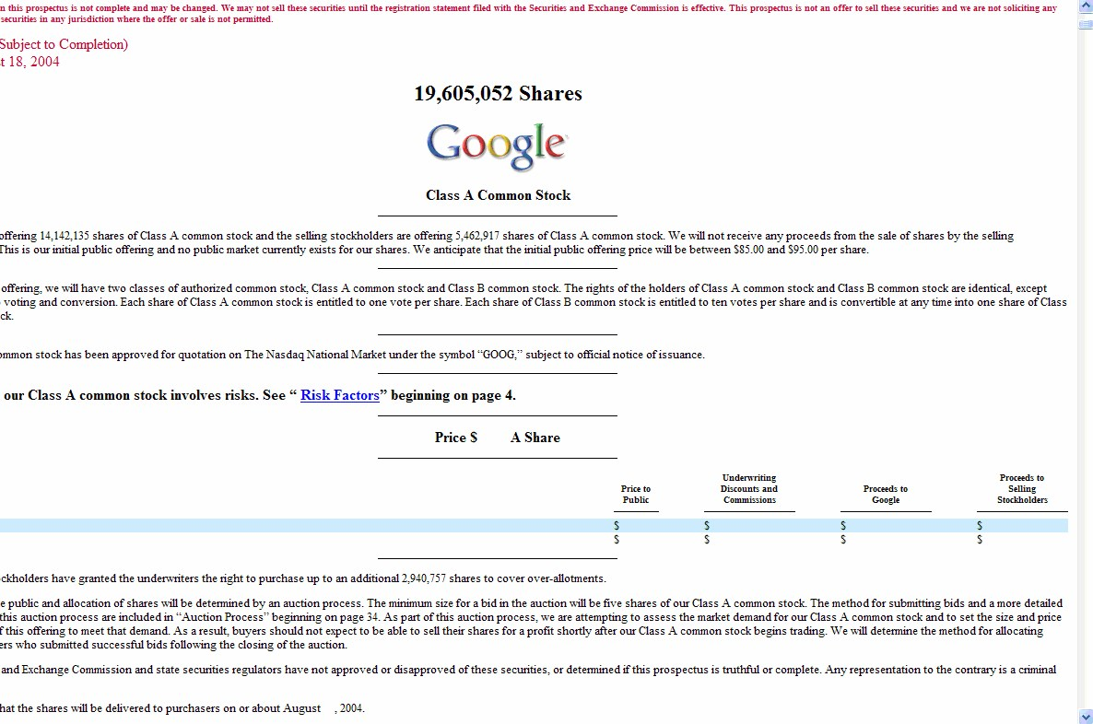

WHAT TO LOOK FOR:

* Offering price
* Risk factors
* Age and track record of the company
* Capitalization of the issuer
* Management of company

WHY IS A PROSPECTUS IMPORTANT? A prospectus offers important details that investors need to know before they invest. Read through all company information and make sure you understand the terms and conditions. Don’t be afraid to ask questions! The unavailability of a prospectus should be a major red flag.

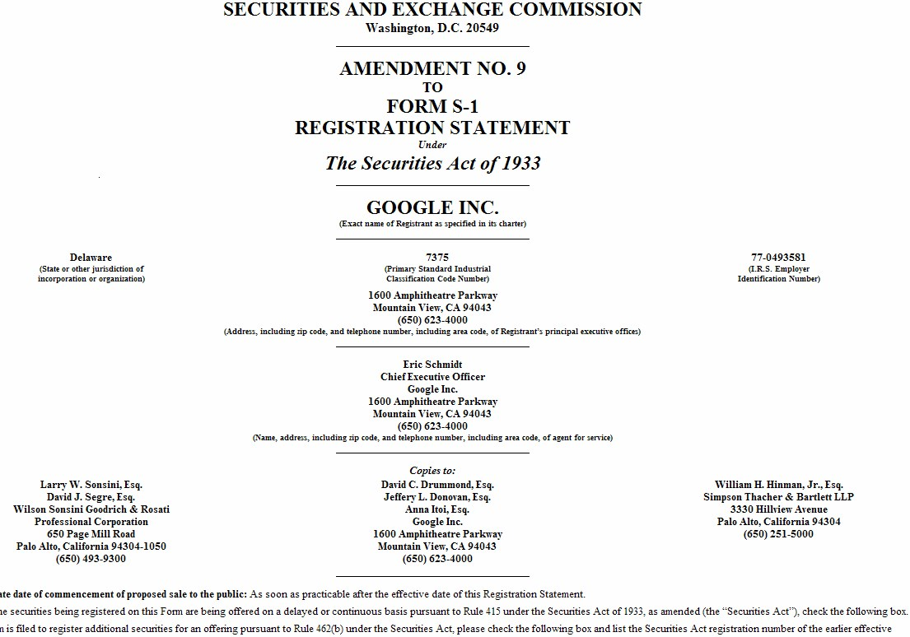

“How to Read a Prospectus: A Guide for Beginning Investors”

Missouri Securities Division

ELEMENTS OF A PROSPECUTS

The front page gives general information such as the issuer’s name, type and amount of securities offered and whether there are any existing shareholders who are selling their shares. It states whether there is or is not a public market. It names the underwriter(s), states the amount of underwriter’s compensation, and notes whether the offering is “firm commitment” or “best efforts.” The front page will also indicate whether the prospectus is effective with the Securities and Exchange Commission (the effective date will appear), or is still “preliminary” (marked in red).

Summary information is a summary of the matters to be disclosed more fully in the prospectus and audited financial statements. Take time to read the fine print in the footnotes. Certain consideration is the risk factor section. Read it very carefully. If it is not included, be very skeptical about the investment. Each risk factor should have substantially more disclosure somewhere else in the prospectus. Look for each one. A litigation section, which summarizes all ongoing material litigation, may or may not be included, depending on whether there is any. Although the risk factors will generally refer to this section, if there is one, it is a good idea to look for one even if it is not mentioned.

The company section gives the history, type of operation, location(s) of operations, and general business plan. This information is expanded in a subsequent section entitled “Business.’’ The use of proceeds section is very important. Don’t invest unless this section can explain how your investment capital will be used. A capitalization table gives the actual and pro forma (adjusted) financial position of the issuer for before and after it receives the funds from the offering. Read the footnotes to this table carefully.

Management discussion and analysis of financial condition and results of operations is one of the most important sections in the prospectus, particularly if you have trouble following the financial statements. This section will tell you how management feels it has performed and gives some idea how the business is “trending’’ with the economy. Careful reading will reveal positive or negative trends on revenues, earnings and expenses. It pays to read this section closely to see where the issuer has been and where it might be going after the new capitalization. A capitalization table gives the actual and pro forma (adjusted) financial position of the issuer for before and after it receives the funds from the offering. Read the footnotes to this table carefully.

Business is an expanded section of the information outlined under the “Company’’ heading and should provide more detailed disclosure as to the issuer’s history, business plan and method(s) of operation. This section contains a subsection entitled “Competition.’’ It is worthwhile to note who and what constitutes the competition against the issuer. This section will also have additional subsections such as Properties, Employees, Patents and Service Marks, and Legal Proceedings. The Management section lists the directors and executive officers, and gives their ages, positions and past experience. It also names the founders or promoters. In the subsection on compensation plans, note any special option plans, stock appreciation rights or other similar common stock equivalents to be paid to management or employers. These equivalents may provide necessary incentives to the employees, management and officers and directors, but an exceptionally larger number may eventually depress the price of your stock.

Quiz

Chapter 3

1. When checking out Suitable Investments, Kim notices an announcement on the door. What does this tell you about the kind of operation this is?

1. Upon leaving the Suitable Investments office, Kim notices a possible prospectus. What is a prospectus and what does it tell you?

1. In the story, the state securities regulator issues a “Cease and Desist” order? What is that?

1. The Securities Enforcement officer goes to the Judge and asks for a bench warrant. What is a bench warrant?

1. State securities laws appear to have been broken, but what other laws might also have been violated?

1. Who is your state / provincial securities regulator?



1. When checking out Suitable Investments, Kim notices an announcement on the door. What does this tell you about the kind of operation this is?

The company is promising high salaries to any individual with no mention of training or qualifications. This is a tip that the brokerage firm employs a separate company for “phone banking.” It’s illegal for unregistered individuals to sell stocks. The company is looking for more employees, meaning they are expanding operations, but they don’t seem to care about the qualifications of the sales force. That’s a warning sign.

1. Upon leaving the Suitable Investments office, Kim notices a possible prospectus. What is a prospectus and what does it tell you?

A prospectus is a formal legal document describing details of a corporation that is created for a proposed offering, but can still be obtained from existing businesses as well. The prospectus includes facts that are important to potential investors and makes investors aware of the risks of the investment.

1. In the story, the state securities regulator issues a “Cease and Desist” order? What is that?

A 'Cease and Desist' order is an administrative order issued by a regulatory agency that commands the individual or company to stop actions that violate the states securities laws.

1. The Securities Enforcement officer goes to the Judge and asks for a bench warrant. What is a bench warrant?

An order issued by the Judge for the arrest of a person.

1. State securities laws appear to have been broken, but what other laws might also have been violated?

U.S. laws involving mail fraud, federal securities laws and consumer fraud laws are all potentially violated.

1. Who is your state / provincial securities regulator?

Your state or provincial securities regulator is your first line of defense against investment fraud. Visit www.nasaa.org to find contact information for your state or provincial securities regulator.

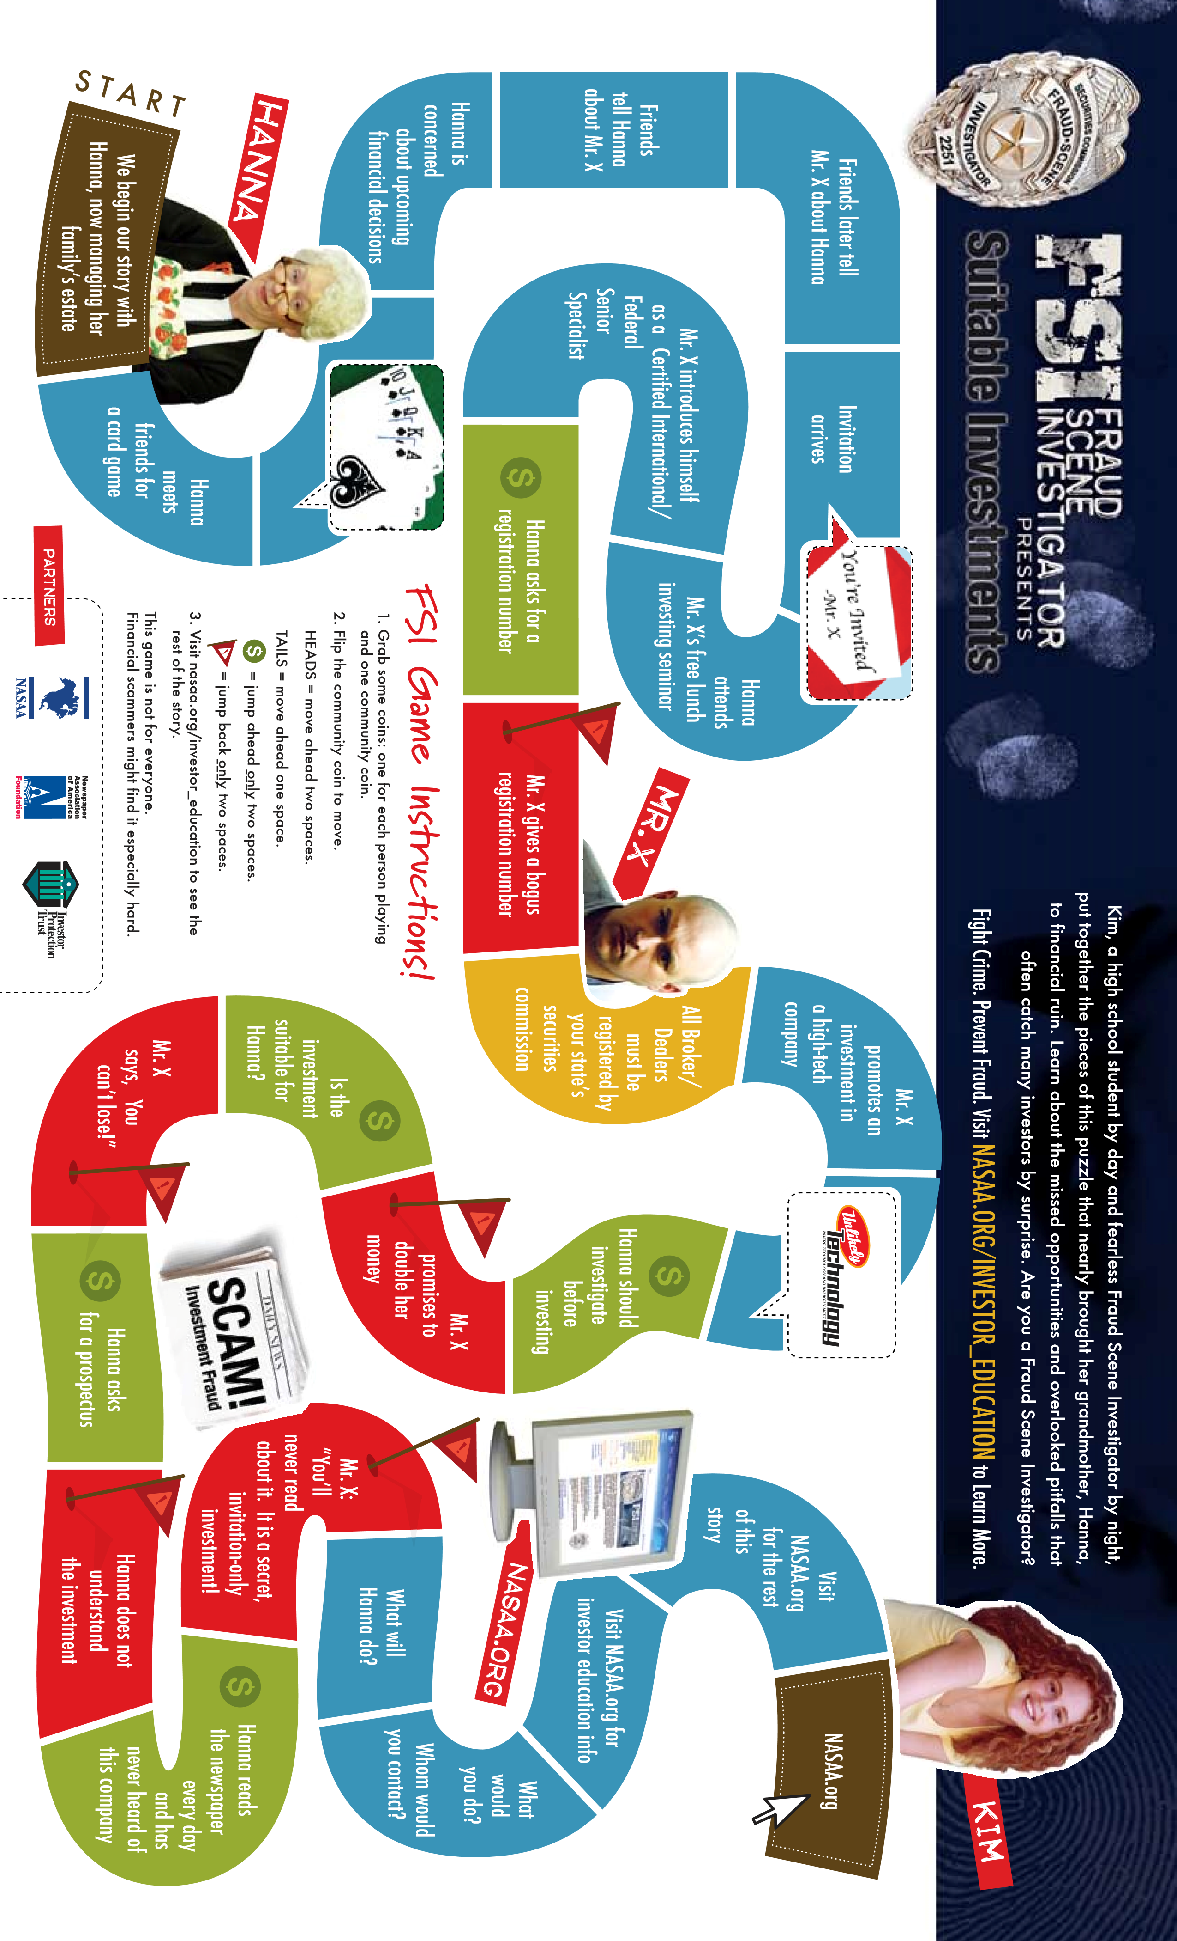

# Additional Resources

## The NASAA Fraud Center www.nasaa.org

Education and awareness are an investor's first line of defense against investment fraud. Each year, investors lose billions of dollars to investment fraud. Investors continue to face increasingly complex and confusing scams.

The fight against fraud never stops because each year con artists discover new ways to fleece the public. Sadly, many of the age-old scams still work to cheat victims of their hard-earned savings. It pays to remember that if an investment opportunity sounds too good to be true, it usually is.

NASAA members share a common goal of protecting investors and are pleased to offer the following resources to help investors protect their savings.

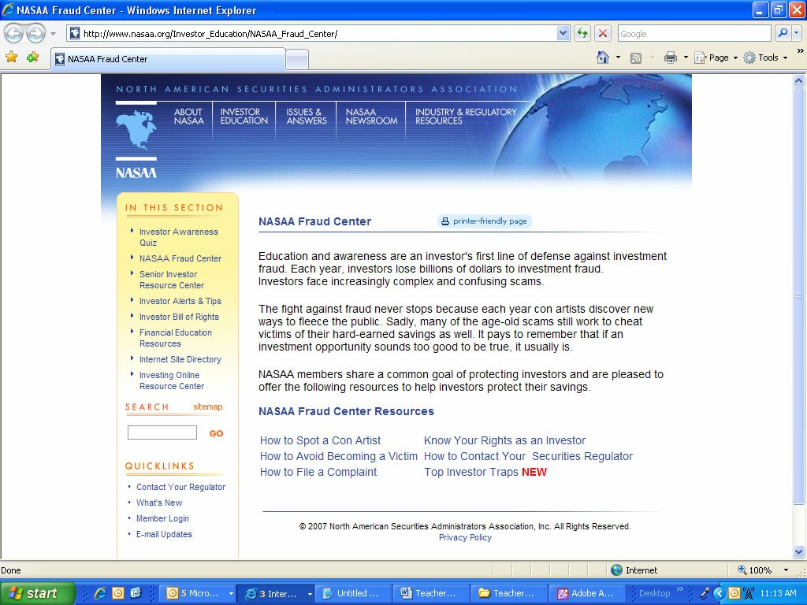

38